Game Viewer (G_View)

Cathal McNally ([mcnallycathal@yahoo.ie](mailto:mcnallycathal@yahoo.ie))

Contents

G_View at a glance 1

Next Button 2

Previous Button 2

Open Folder Button 2

About Button 2

XML Pane 2

Image Pane 2

What is G_View 2

How G_View Works 4

G_View Tutorial 4

Preparation 4

Create the Image file 5

Create the XML Document 8

Conclusion 10

# G_View at a glance

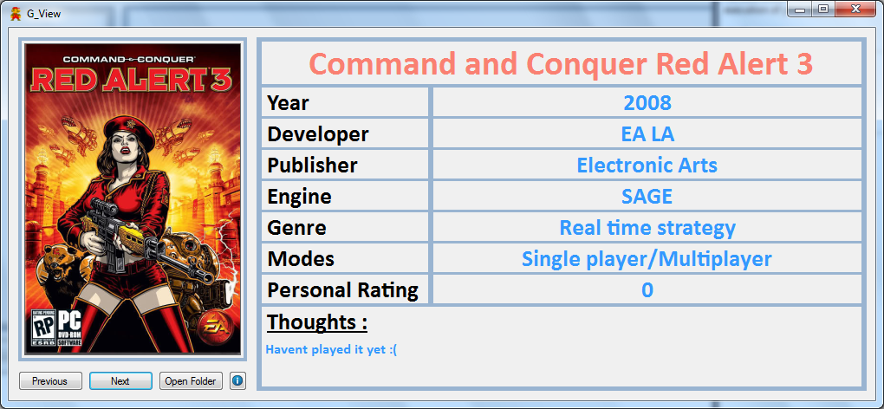

## Next Button

Pressing the Next button will show the Next Game’s image and info.

## Previous Button

Pressing the Previous button will show the previous Game’s image and info.

## Open Folder Button

This will open the current games directory making easily accessible so you can then go and install the game.

## About Button

This will provide some basic “About” information on G_View.

## XML Pane

This will display info parsed from a games corresponding .gvx

## Image Pane

This will display a games corresponding Cover art as a .gvi

# What is G_View

If you are anything like me when it comes to keeping a tidy PC with nice neat folder structures G_View could be a nice edition.

Do you keep a collection of your games .ISO’s on your hard drive locally like i do? I tend to back up my game discs to my hard drive as its easier to mount them than go hunting for a disc.

I also keep the ISO’s of games ive downloaded over the years. I keep all of the games in a tidy folder structure that i can easily navigate to find a game i would like to install.

Below is an example of my Games folder Structure.



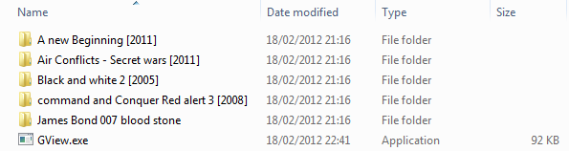

G_View sits on the Root Directory

For G_View to find a game in your Root directory it will be looking for 2 seperate files in each game folder.

*.gvi 🡪 (game viewer image)

*.gvx 🡪 (game viewer XML)

A .gvi is basically a .jpg renamed to .gvi

A .gvx is basically a .xml renamed to .gvx

The reasoning behind renaming .jpg’s and .xml’s to the above format was to prevent the program from picking up stray jpegs and xml documents that may reside within some game folders.

Blelow is the folder structure from inside one of my game’s folders

Although not neccessary i divide my Folders up into GAME and Gview. I do this for every game. The GAME folder holds the backup .Iso image of the game. The Gview folder holds the files required by G_View.



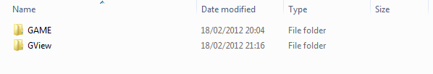

Below is the Folder Structure of Gview



This is the contents of the Gview folder

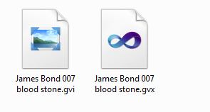

I have set the .gvi to open with Windows Photo Viewer and since its simple a .jpg renamed to .gvi it will open it.

I have set the .gvx to open with Visual studio but you can open it with Notepad, Worpad or any other text editor really since its only text.

# How G_View Works

G_View needs to be placed at the Games folder Root.

It will search every folder in the Games folder looking for both a .gvi and .gvx file. The .gvi is the cover art JPEG of the game while the .gvi is a basic xml document that holds some basic facts about the game. You will need to manually download the image and save it as a JPEG and then rename its extension to . gvi (i cover this in a tutorial below) whereas you will need to source the game info to fill the fields in the .gvx (tutorial will cover this as well as provide a template to get started from)

Once G_View finds the .gvi and .gvx in a folder it add’s the game to the array and moves onto the next folder and repeats until there are no more .gvi and .gvx files to load. You can then traverse through the array with the next and previous buttons.

# G_View Tutorial

## Preparation

Assuming you are going to adopt my approach to structuring your directory of Games it shoul look something like this.



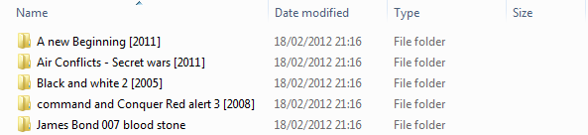

Go inside Each folder and take your Game ISO or files and place them inside a folder called “GAME”.

Now Create a folder called “Gview”. (Not neccessary but keeps it tidy)





Now for the game i am currently working on its James Bond 007 – Blood Stone

I tend to Google the name of the game followed by cover to find a suitable game cover for the image. Find a suitable image and download it (Try and get one in the aspect ratio of a cover!)

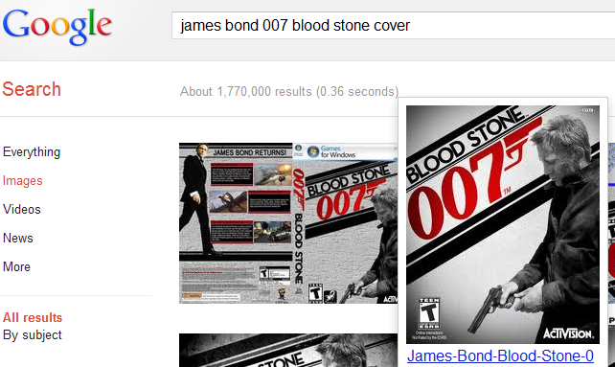

## Create the Image file

Now that you have downloaded the image cover for the game copy it to your Gview directory you created earlier



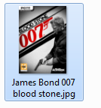

If you dont see the extension you have to enable it. Go to Organize 🡪 Folder and Search Options

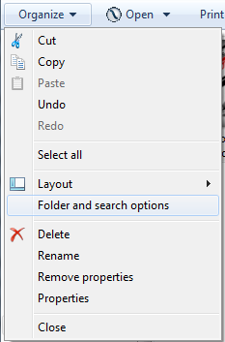

On the View Tab UNCHECK “Hide extensions for known file types”

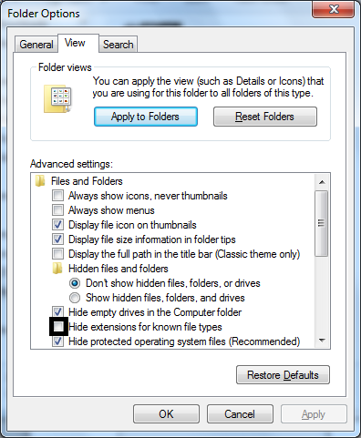

Now return to the Gview folder and you should see .jpg at the end of the image.

Click the image and rename it from “James Bond 007 blood stone.jpg” to “James Bond 007 blood stone.gvi”

You will see the following 🡪 Click yes

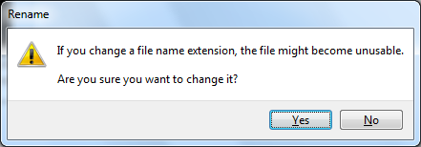

It should now look like or along these lines. Dont fret if the image isnt coming up i think you need a restart for that.

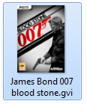

Right click on the .gvi file and go to properties. In properties select “Change” and select Windows Photo viewer or Paint or some image editing software to open the former Jpg. Select ok and move onto the next section.

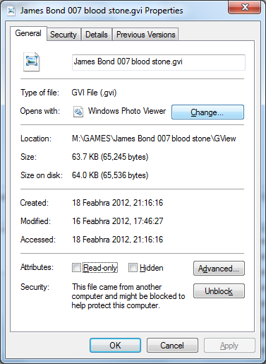

## 

## Create the XML Document

Now in the same GView folder right click on white space and select New 🡪 text document and call it james bond or w/e.

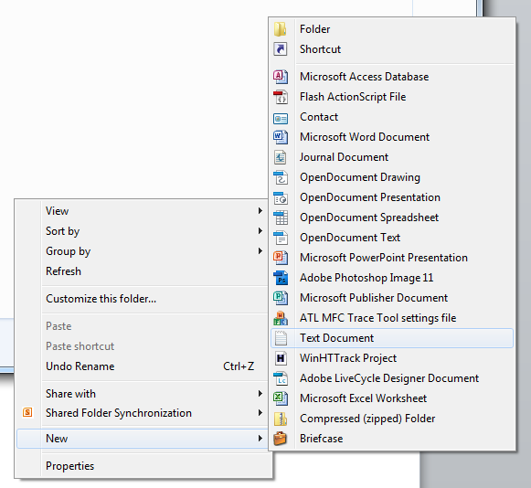

Now rename this file to have the extension of .gvx

Go to properties of the .gvx file and this time you can select Visual studio, Notepad or Wordpad to open this XML document which is really just text.

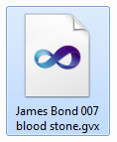

Assuming you selected Notepad open the .gvx and paste the following text into it.

<?xml version="1.0"?>

<Game>

<name>James Bond 007 blood stone</name>

<year>2010</year>

<developer>Bizarre Creations</developer>

<publisher>Activision</publisher>

<engine>Horizon</engine>

<genre>Third person Shooter</genre>

<modes>Sp/Mp</modes>

<personalRating>0</personalRating>

<thoughts>Havent played it yet :( </thoughts>

</Game>

Then save the document and run Gview which should be a folder above the actual game folder(in this case the james bond 007 – blood stone folder). You should see the image and info when you press next if all went well.

If something went wrong have a look at the “SampleUsage” folder and compare it to your own.

Im not going to explain in complete detail what XML is and how it works. All you need to do is follow the above template for your own Games info that you can source from Wikipedia.

<Game> is the Root Node 🡪 just make sure its always there

<name>🡪 is for the game name

<year> 🡪for the release year of the game

<developer>🡪 is for the game developer

<publisher>🡪 is for the game publisher

<engine> 🡪is for the game engine

<genre> 🡪is for the game genre

<modes> 🡪 is for game modes such as single or mulitplayer

<personalRating> 🡪is a figure from 1-10 you can set on what you thought the game scored

<thoughts> 🡪you can place a personal message on what you thought the game was like.

# Conclusion

G_View is primative and i understand that as this is the 1.0a release.

I only spent around 6 hours coding on it and its more of a personal project as i have great pride in my games collection. If there was an IMDB of games (that was half decent) i would parse xml from html online and that would save users having to download images and xml files manually. Until then i am happy so far with its usage.

I hope you Enjoy it

Kind Regards

Foo